**Knowledge Discovery Management Project**

**Increment-III Report**

**Social Trend Analysis**



**Team:**

**Ashok Rudraraju,**

**Aditya Deshpande,**

**Tej Kiran Meka,**

**Mahesh Vemula.**

**Tasks Completed:**

1. Developed map reduce algorithm and ran classification algorithm.

2. Pushed classified data to solr to access from cloud

**1. Developed Map reduce algorithm and Classification Algorithm:**

For this increment we have developed Hadoop Map reduce algorithm using Java to filter and sort the large dataset that we have extracted from twitter. Then we have classified the dataset into different classes as country and city names. Then we extracted the output data in the json format.

Screenshots of the classified output:

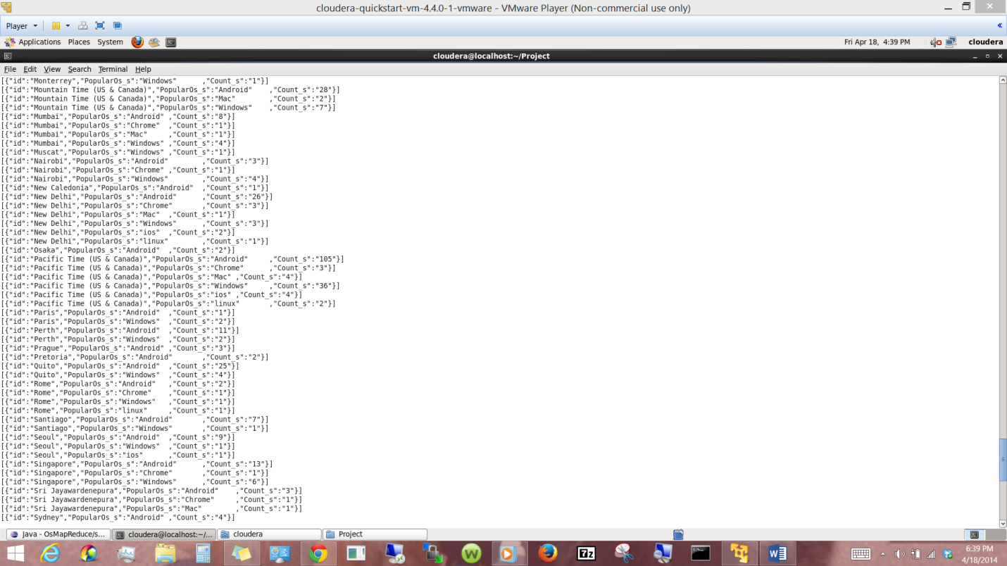

Following Screenshot presents the Map reduce algorithm that we run.

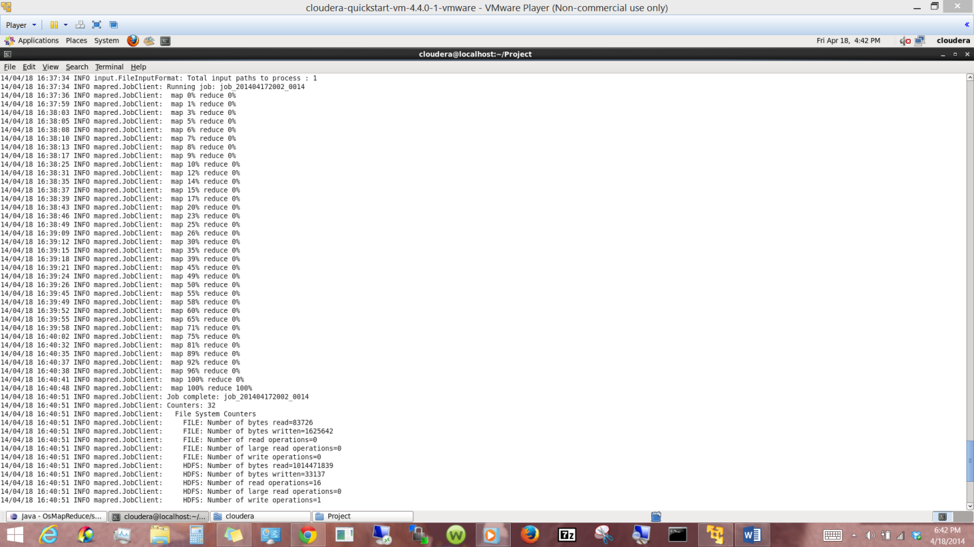

**2. Data storage in cloud:**

In this part we used solr to have storage and service.

Solr gives us storage and query service:

We pushed the output json file to solr using curl command as shown in the tutorials.

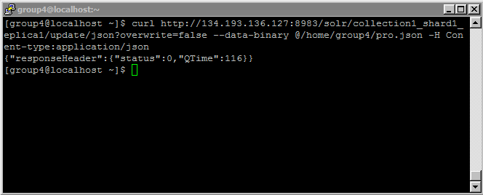

We accessed the uploaded data using the queries on id in solr.

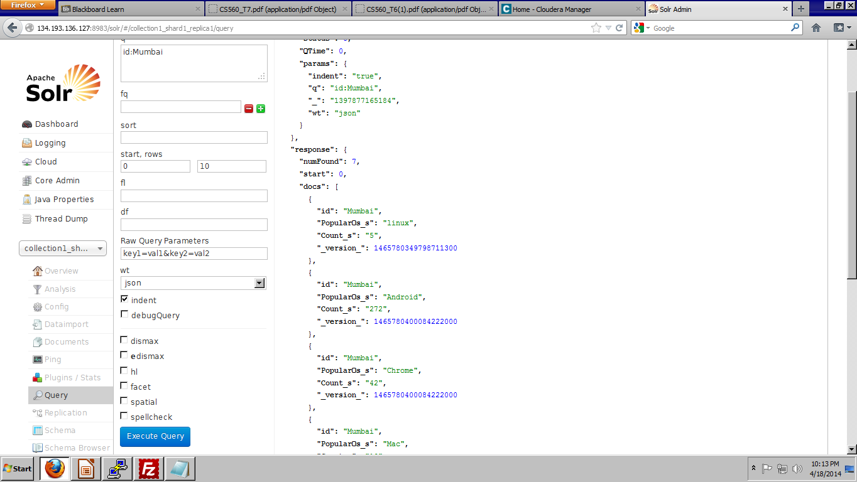

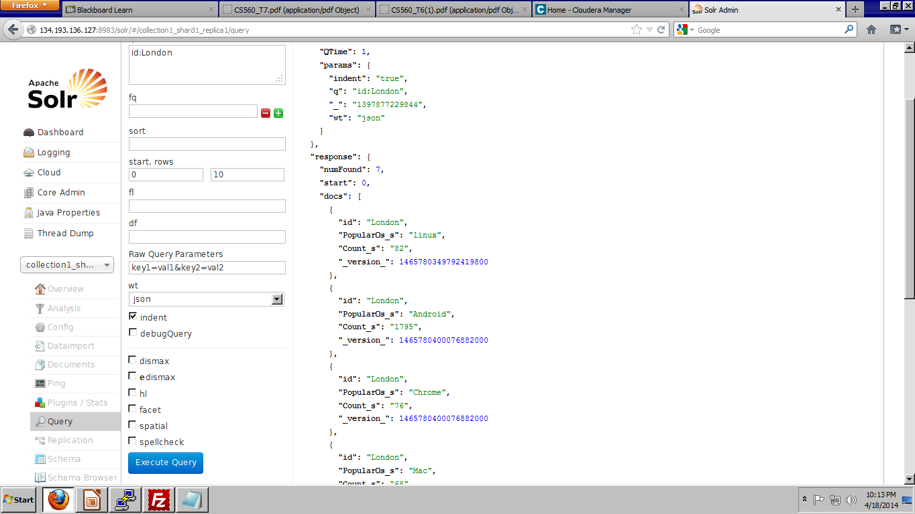

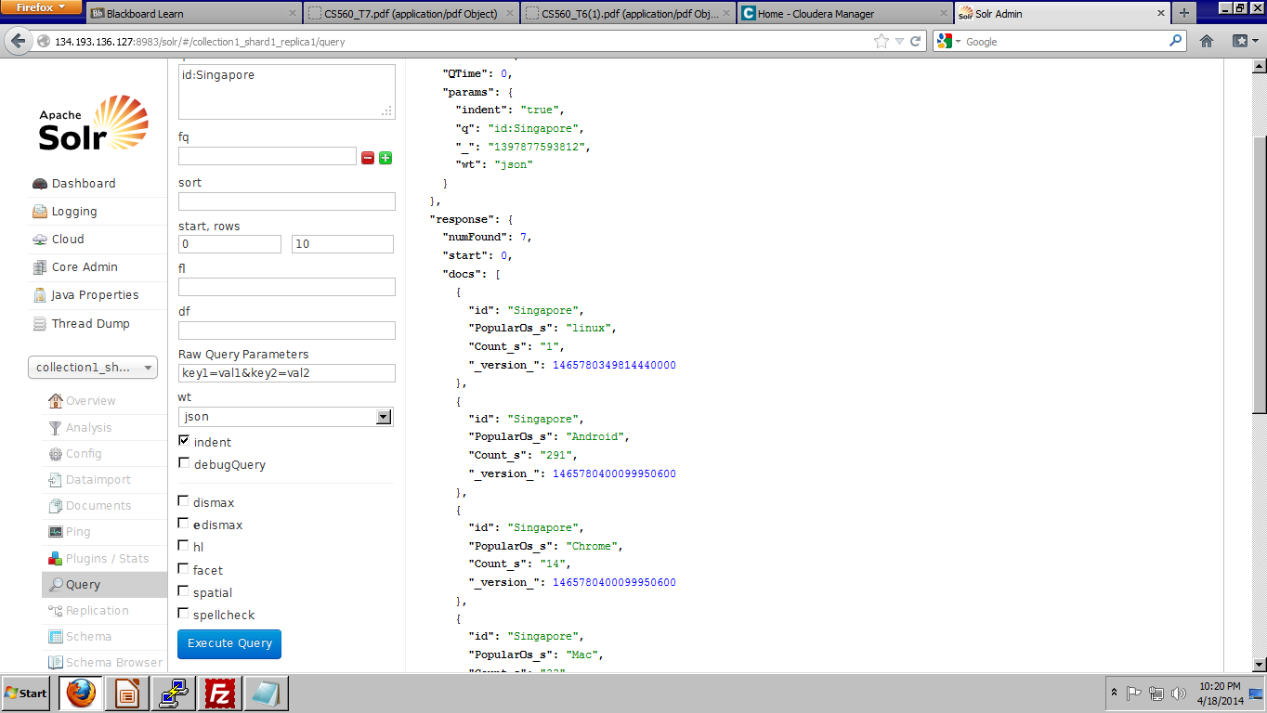

**Tasks to be completed:**

We have to use this json data uploaded to solr and we have to develop web service to parse this json data to represent through user interface.

**Scrumdo Link:**

https://www.scrumdo.com/projects/project/kdm-project-scrum/summary#